**See How Students Transformed Their Rooms On Campus!**

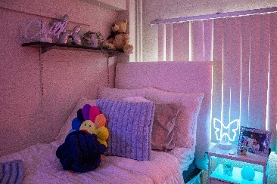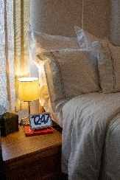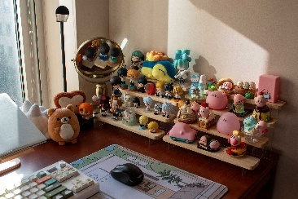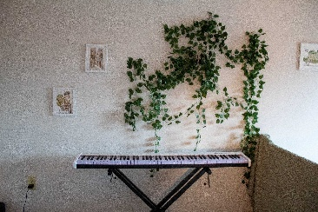

There are so many different ways to make your space here at Rutgers feel like home. To give you some inspiration, we went on a search to find the most uniquely decorated rooms on campus and highlighted our favorites down below. Check out how these students transformed their spaces and made it their own!

**Share What You Love**

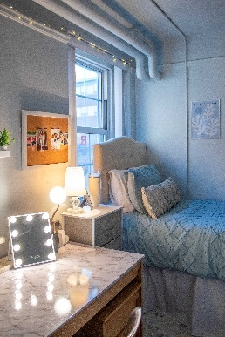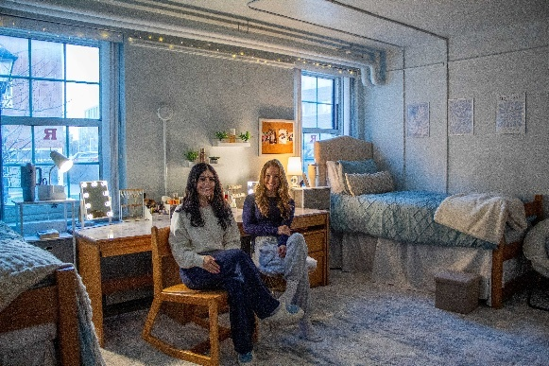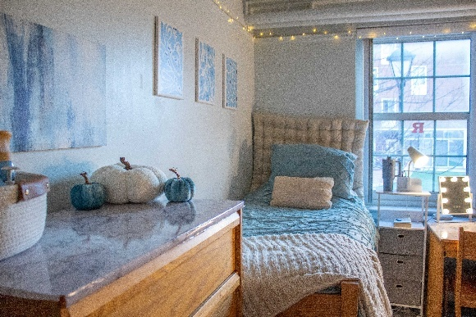

Coordinating dorm decorations can be a great bonding activity for new roommates. Sophomores Miranda and Julia began their friendship as incoming freshmen by planning their matching decor for their first dorm over text. They had so much fun decorating that they meticulously planned out this year’s dorm room to make it even better. With coordinating bedspreads, vanity-style desks, matching nightstands, and even Stanley cups to match the color scheme of their College Ave dorm, Miranda and Julia created a space that reflects their friendship and shared passion for decorating.

**All Things Cute and Artsy**

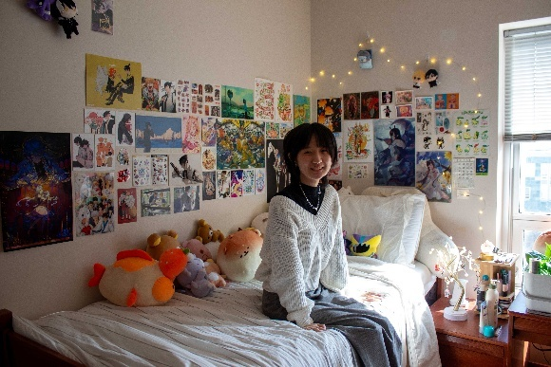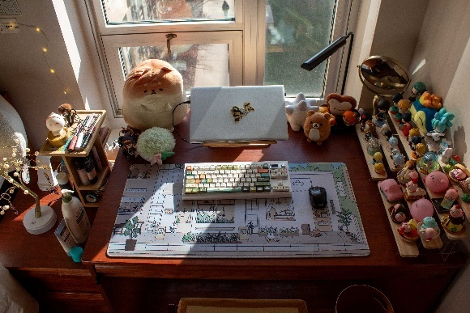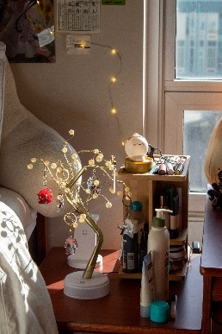

Having a space filled with your favorite art and cute things that you love can immediately uplift your mood. Claire went all out to fill her Livingston room with posters of her favorite video games and TV show characters, as well as completely original art that she has collected over the years. She especially loves collecting cool plushies from her favorite brands and having all her figurines on her desk, which motivates her to work harder so she can afford to keep growing her collection.

**Maximum Cozy Vibes**

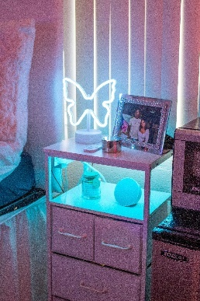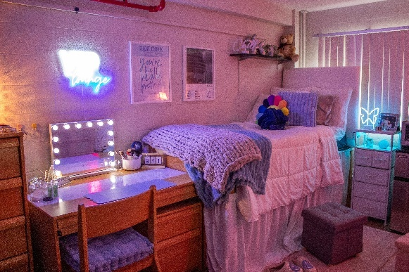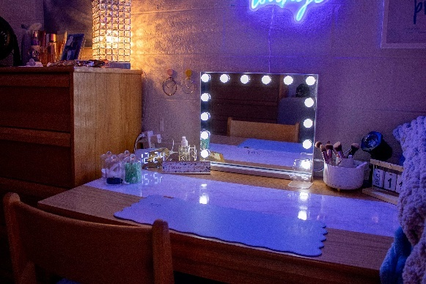

As two people who love ambient lighting, Caylin and her roommate decided to fill their College Ave dorm with moody, comforting lights so they can easily unwind in their room. Caylin took inspiration from one of our finalists from [last year’s contest](https://ruoncampus.rutgers.edu/stories/check-out-these-amazing-rooms-campus-2023), using a similar light-up vanity, faux neon lights, and marble contact paper in a way that still reflects her personal style. She added some personal items to her room to remind her of home, incorporating her childhood Teddy Bear and various pictures of her loved ones that hold sentimental value.

**Create a Tranquil Space**

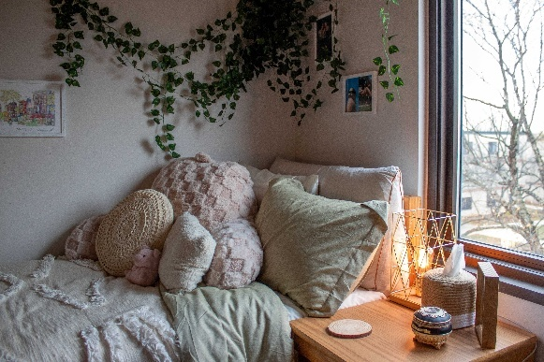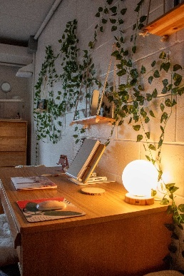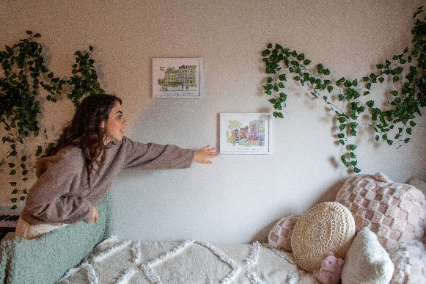

Focusing on including decorations that relax you can transform your space into the perfect tranquil environment. Grad student Sara filled her Busch room with faux plants that remind her of the real plants she has back home, and paired with the wooden furniture makes her feel like she’s in nature. With some meaningful touches like gifts from her loved ones and memories from her past trips filling in the rest of the space, Sara has truly made her room at Rutgers her home away from home.

**Express Yourself to The Max**

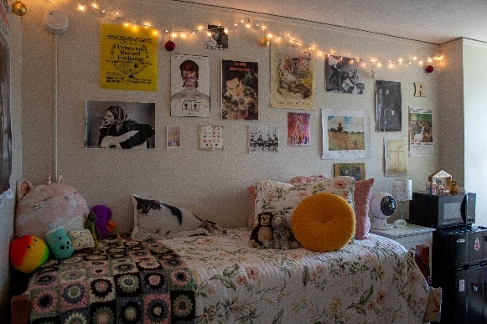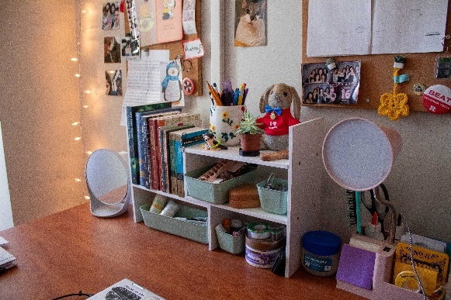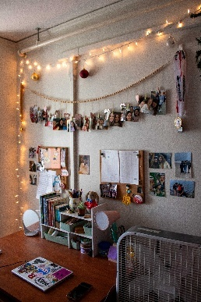

If you have an eclectic, maximalist style, then filling every inch of your space with decorations can turn your Rutgers room into the perfect hangout spot. Audrey took advantage of all the space in her Douglass dorm, describing her style as an “organized clutter” of all the things she loves as well as her favorite mementos. Audrey creatively redecorates for every holiday, from Halloween in the fall to Easter in the spring; she was decorated for Christmas when we went to visit her, having ornaments and garland hanging up alongside her year-round decorations.

**Keep It Old School**

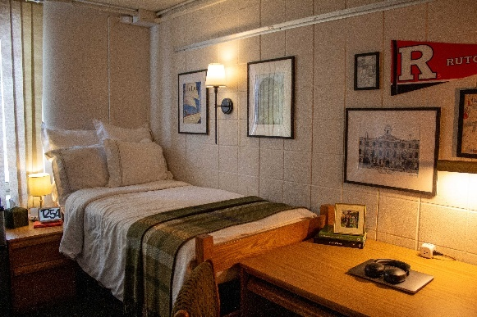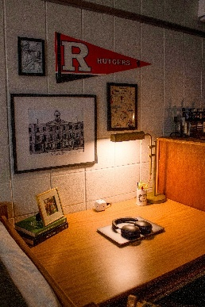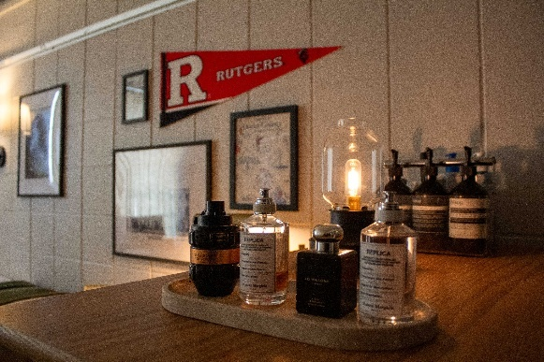

Drawing inspiration from the traditional American university style and mixing it with sleek modern amenities can create a perfect blend of old and new. Nathaniel completely transformed his Busch dorm room into a timeless, classic space by decorating in an “American collegiate” style, as highlighted by his framed posters, Rutgers pennant, and incorporation of vintage-style lighting and bedspread. His favorite poster is his vintage tourism brochure from 1950s Ocean County, which is actually where he grew up.

**Pretty In Pink**

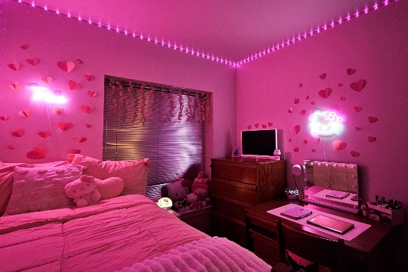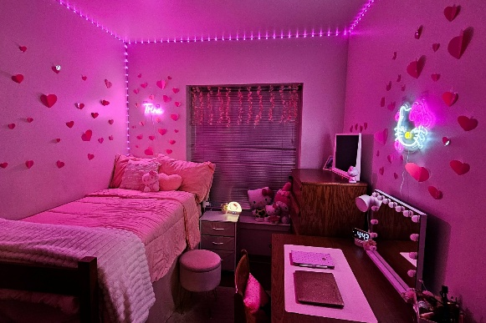

Always being surrounded by your favorite color can instantly light up your mood as well as reflect who you are. Kathrina has always been described as “bubbly” by her friends, and her bright pink room and cute decorations suit her personality perfectly. By decorating her dorm with her favorite things, like all her Hello Kitty decor from home as well as pretty accents like hearts and flowers, makes Kathrina feel that her dorm here at Rutgers is almost just as homey and comfortable as her room back home.

**Simple Yet Stylish**

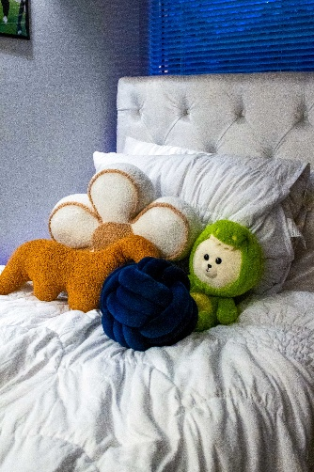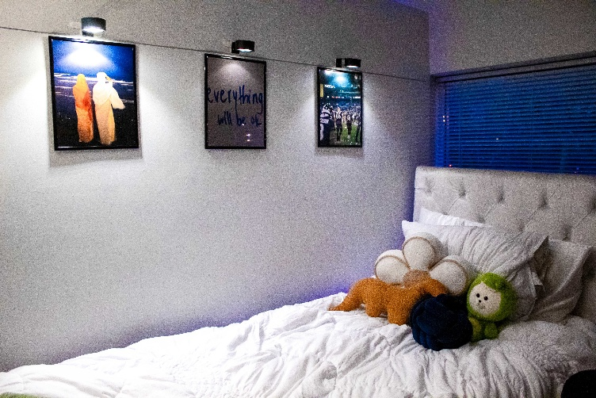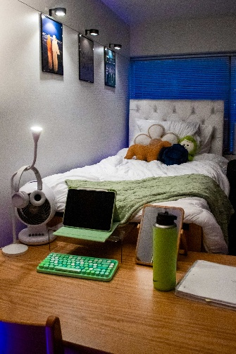

Focusing on having the essentials and adding a few personal touches is sometimes all you need to feel at home. Sunna created her cozy yet clean space by picking out simple pieces for her dorm that still reflect her personality. Running LED lights on the floor beside her bed creates a sleek lighting effect on the wall and ceiling while attaching spotlights with command strips over her posters highlights the images in a subtle but effective manner. Sunna chose posters that represent the most important and interesting things to her; her religion, staying motivated, and The Ravens, her favorite football team.

The featured rooms are finalists of the 2024 Room Decorating Contest. Congratulations to Miranda and her roommate Julia, our first-place winners! Special thanks to our sponsors [Kite and Key](https://kiteandkey.rutgers.edu/) and [Rutgers Cinema!](https://www.rutgerscinema.com/)

We want to give a very special shoutout to IKEA for sponsoring this year’s Room Decorating Contest! [IKEA Elizabeth](https://www.ikea.com/us/en/?cid=a1:ps%7Ca2:se%7Ca3:US_ActivateConsumerLed_Behavioural_0_AO_0_en_Search_Brand_HFBMUL_0_BMM_IKE-IKE-084_IKEA_FY24_Bing_ROAS_AOH_Text_Br_BMM%7Ca4:+IKEA%20+Furniture%7Ca5:p%7Ca6:bing%7Ca7:cq%7Cid:IKEA%20Branded%20GM%7Ccc:915&msclkid=986886653154122a2337e1ef9f269073&utm_source=bing&utm_medium=cpc&utm_campaign=US_ActivateConsumerLed_Behavioural_0_AO_0_en_Search_Brand_HFBMUL_0_BMM_IKE-IKE-084_IKEA_FY24_Bing_ROAS_AOH_Text_Br_BMM&utm_term=+IKEA%20+Furniture&utm_content=eComm%20Furniture&adfcd=1737141909.lPR89A6LAkukZee5WX8ilg.MTQwMDYxOCwxNDg3MDYy) donated 8 gift bags to Residence Life for the contest, which we gave out to each of our finalists. Congratulations to all of our 8 finalists this year!

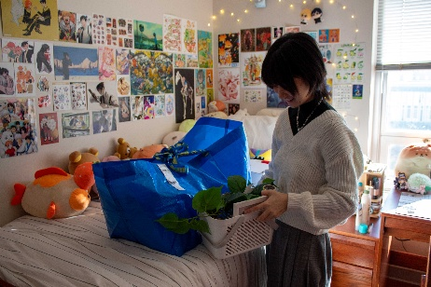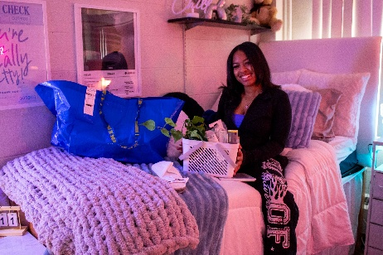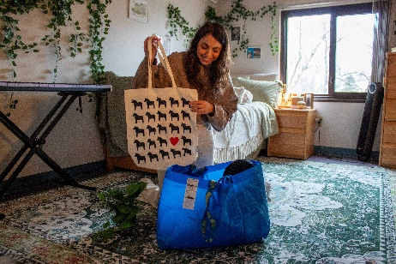

Thank you for taking the time to check out this year’s finalists, and feel free to share this article with your friends if you found some décor inspo to use for next year! If you have some room ideas of your own you’d like to share, then show us! — @Rutgersreslife on [Facebook](https://www.facebook.com/rutgersreslife/), [Twitter](https://www.google.com/url?sa=t&rct=j&q=&esrc=s&source=web&cd=&cad=rja&uact=8&ved=2ahUKEwiOyvf5z_uCAxV-jYkEHTRaDM8QFnoECBAQAQ&url=https%3A%2F%2Ftwitter.com%2Frutgersreslife&usg=AOvVaw0-QkhnEdd9IcXUuX1FKxHl&opi=89978449), [Instagram](https://www.instagram.com/rutgersreslife/).